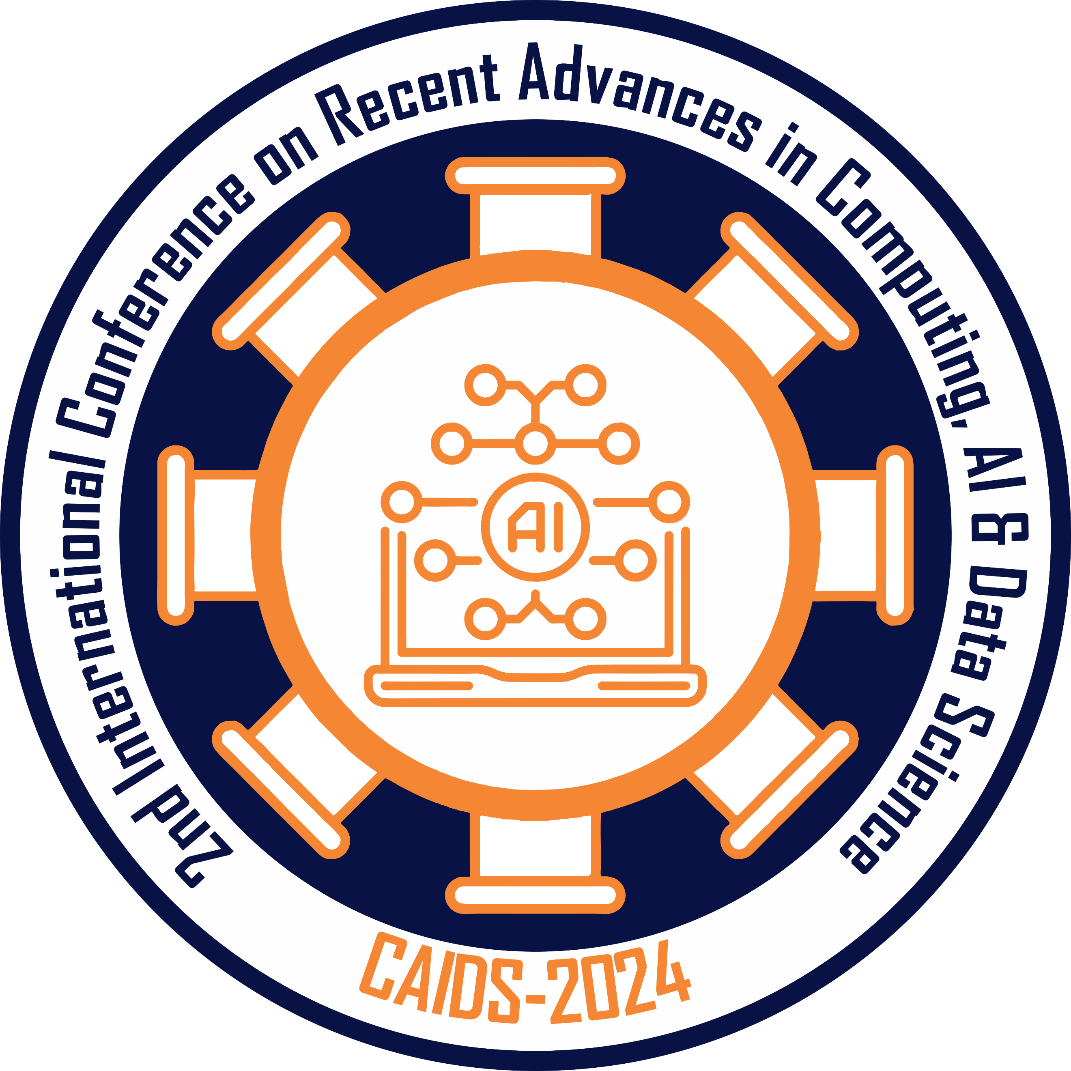
CAIDS-2024
Registration Form
2nd International Conference on
Recent Advances in Computing, AI & Data Science - 2024
Islamabad, Pakistan, November 21 - 22, 2024
https://caids.org.pk/
The registration fee will only cover participation in the conference and the conference kit. Please note that this registration fee does not include transportation fee, lunch and dinner fees, accommodation fees, and after-conference tour fees.

All questions and inquiries concerning registration and payment should be addressed to:
info@caids.org.pk

CONFERENCE PARTICIPANT | PLEASE KINDLY FILL IN A SEPARATE REGISTRATION FORM FOR EACH CONFERENCE PARTICIPANT
This information will be used for the list of participants and correspondence. | Title 1.Dr. 2. Mr. 3. Ms. 4. Prof. |  |  | Name
 | Affiliation
 | Mailing Address
 | City, Zip, Country
 | Phone |  | Fax |  |  |  | Email
ACCEPTED PAPER INFORMATION | Paper ID: Authors:  Title of the paper:

REGISTRATION FEE |  |  | Registration Fee
REGISTRATION FEE | Author Registration | Paper Registration (Student) | □ PKR 5,000
REGISTRATION FEE | Author Registration | Paper Registration (Faculty Member) | □ PKR 8,000
REGISTRATION FEE | Author Registration | International Presenters | □ USD 80$
REGISTRATION FEE | Author Registration | Poster Presentation | □ PKR 3,500
REGISTRATION FEE | Attendee  Registration | Standard Registration | □ PKR 600

PAYMENT METHOD |  | □ BANK tRANSFER  □ Easypaisa tRANSFER
 | Total Amount (PKR-USD) |  | Bank Name | Remitter | Date
Bank Transfer

